Code Documentation

# Contents:

1. Main.gd
   1. Button Press
2. Game.gd
   1. Generate Player Life All
   2. Generate Player Life
   3. Answer Input
   4. Check Answer
   5. Answer Highlight
   6. Damage
   7. Consume AP
3. CreateAssignment.gd
   1. Add Items
   2. Add Difficulty
   3. Add Question
   4. Clear All
   5. Confirm Button

1. Main.gd

1.1. Button Press:



Description:

Upon pressing on the register button, user will be navigated to Register.gd

General Usage:

Func _on_<Button Name>_pressed() -> void:

get_tree().change_scene(“<Path to next tscn file>”)

Parameters:

None

Return:

None

2. Game.gd

2.1. Generate Player Life All:

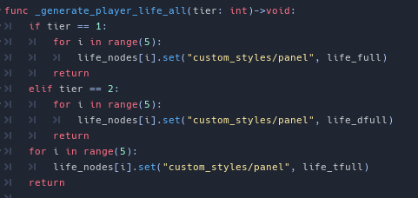

Description:

Modify the 5 element HP array of player to display correct visuals tier by tier.

Parameters:

T - Integer to represent which tier of HP

Return:

None

2.2. Generate Player Life:

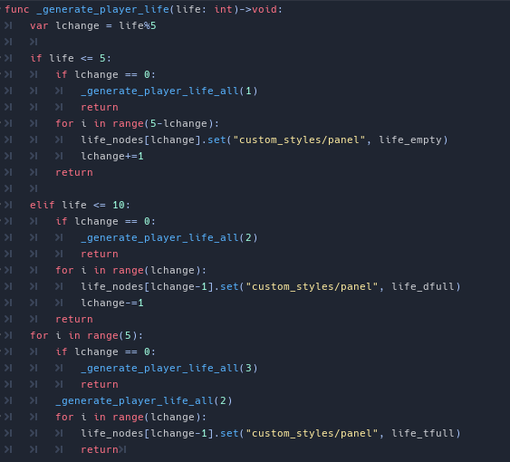

Description:

Modify the five element HP array of the player based on the player’s Life Index.

Parameters:

Life - Integer representing player’s total HP (lifes_idx)

Return:

None

2.3. Answer Input:

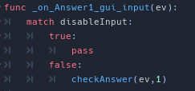

Description:

Waits for player input, upon detecting player input, either by mouse press or screen tap, calls checkAnswer().

Parameters:

Ev - player input event

Return:

None

2.4. Check Answer:

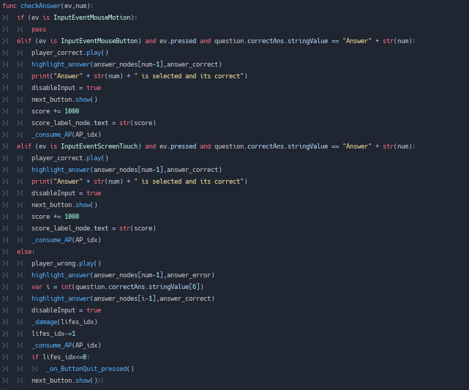

Description:

Checks input answer with database. If selected answer matches the correct answer score is incremented by 1000, else damage() is called. Consume_AP() will be called upon answering. If player HP is 0 player will exit back to main menu.

Parameters:

Ev - input event by player

Num - integer representing choice of answer

Return:

None

2.5. Answer Highlight:



Description:

Highlights the correct answer after player input has been processed.

Parameters:

None

Return:

None

2.6. Damage:

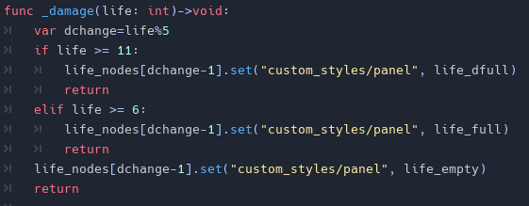

Description:

Modifies the HP array of player based on current health of player.

Parameter:

Life - current HP of player

Return:

None

2.7. Consume AP:

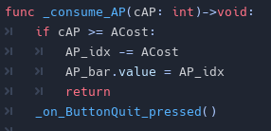

Description:

Modifies the player’s AP bar upon answering a question. If player’s AP is lower than the cost of the question player will be brought back to the main menu.

Parameters:

cAP - integer representing player’s current AP

Return:

None